Dear SNS

Please find the below screen shots as you requested.

Kindly note that, the user currently generating report and doing manual move using RF.

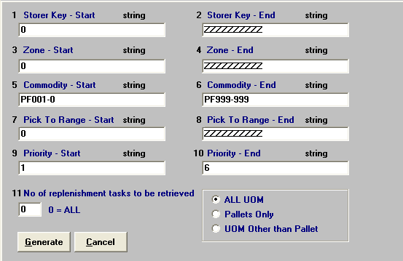

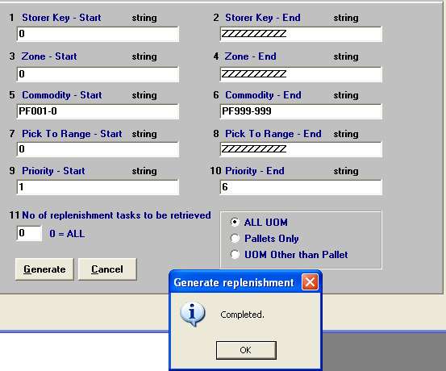

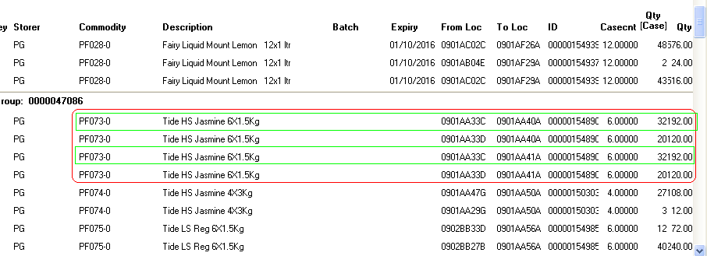

The item PF073-0 having 32 cases available in 0901AA33C location and the full available quantity suggested to the location 0901AA40A.

But the same quantity and location suggesting to 0901AA40A location also in next line. Please find the below screen shot for the available quantity in the source location.

cid:image014.png@01D09D0C.9A806AE0

Please let me know if you need any more clarification on this.